Github diet notes:

There were many screens that may need some instructions during the install/setup phase.

…Verification, is Desktop App in your Applications folder, which existing repositories to make available,…

Most of them are “obvious” but I can see a student getting nervous.

Once I had Desktop App installed it showed me this:

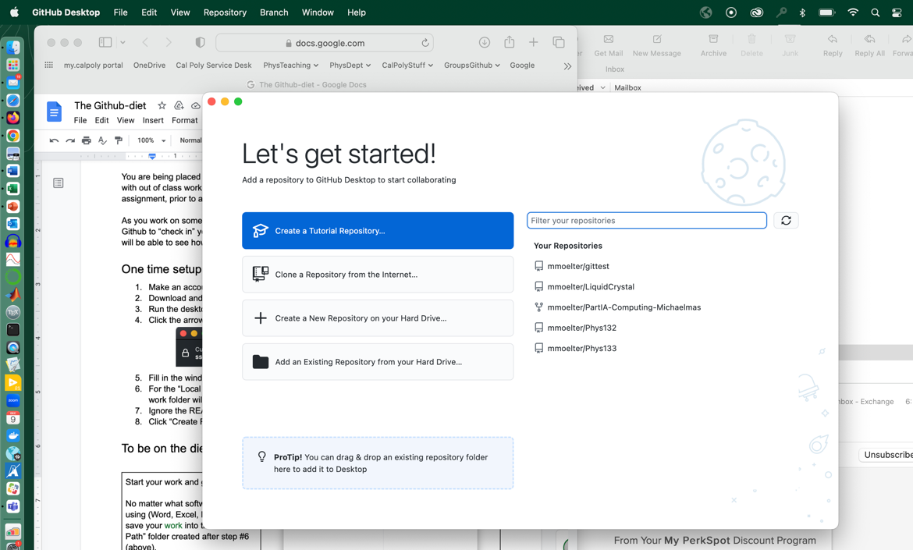

Which gave this

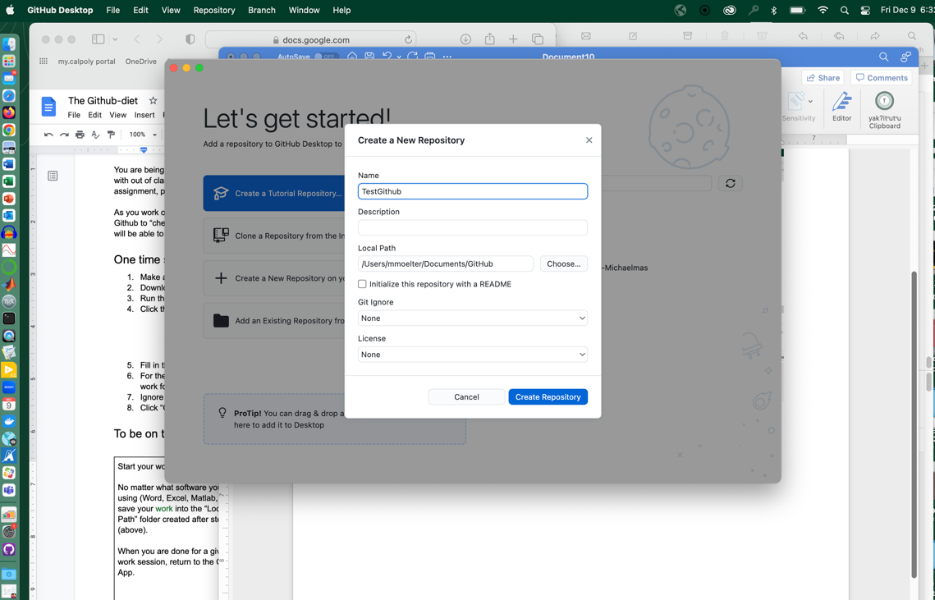

That gave this

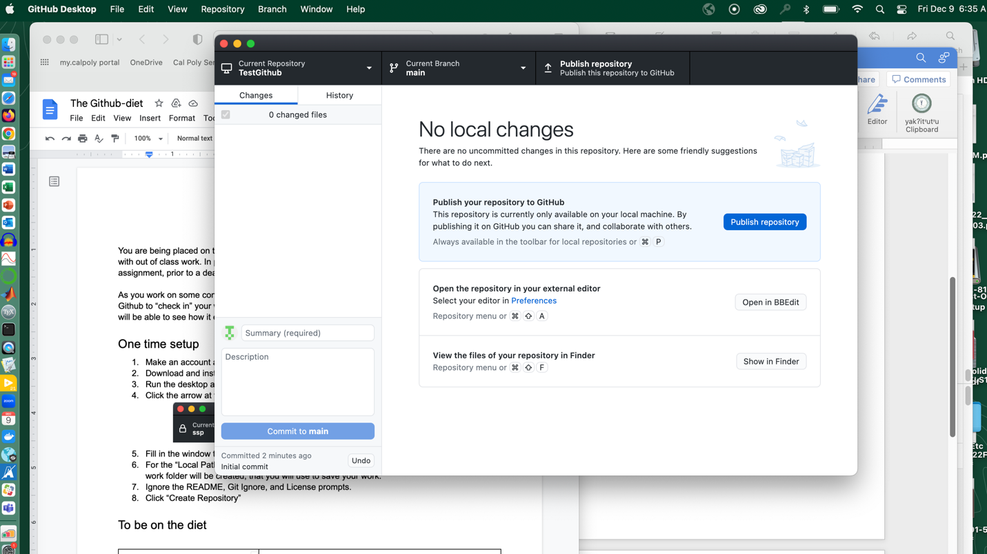

Since I want you to see it I chose Publish